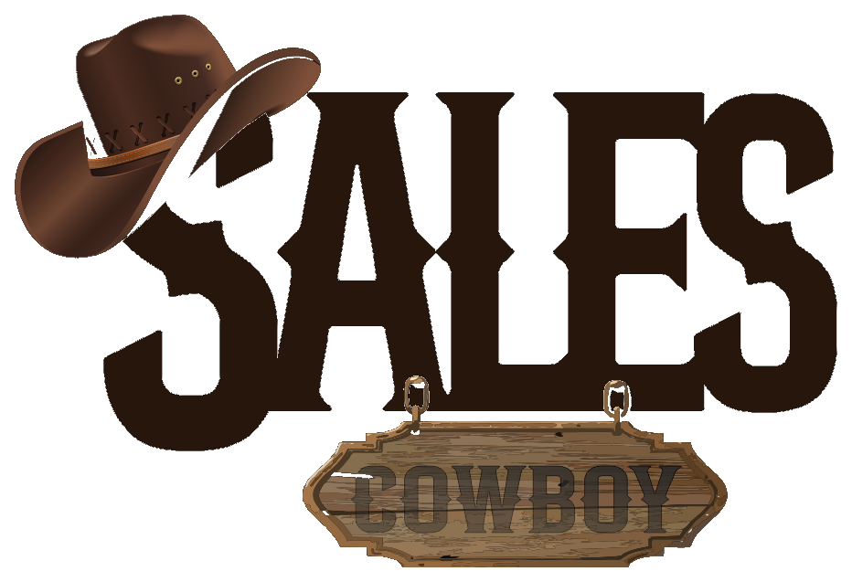 SALES COWBOY  Marketing Solutions • Hospitality Revenue Engineering  Red Brick House, Peace Land Estate, Ogombo, Ajah, Lagos, Nigeria  hello@salescowboy.com.ng • +234 810 493 3232 • salescowboy.com.ng | DIGITAL REVENUE AUDIT  REF: AUD-OLY-2026-004  DATE: November 06, 2026  STATUS: CONFIDENTIAL
――――――――――――――――――――――――――――――――――――――――――――――――――――――――――――
DIGITAL SEARCH VISIBILITY, REVENUE & OPERATIONS AUDIT
Monetizing 418 Google Reviews, Direct Booking Engine, 24/7 WhatsApp AI Concierge & Hotel Management Software
PREPARED FOR (CLIENT):  Olympus Hotel & Suites  27/29 Ibadan-Abeokuta Rd, Fatimah B/Stop, by 110 R/About, Oluyole, Ibadan  Phone: +234 913 905 2671 / +234 815 951 1334  Facilities: Rooms, Pool, Bar, Restaurant, Club & Snooker Lounge | PREPARED BY (AUDITOR):  Sales Cowboy Marketing Solutions  Hospitality Revenue Engineering Division  Ajah, Lagos • salescowboy.com.ng  Contact: +234 810 493 3232

HEALTH SCORE  48 / 100  UNMONETIZED ASSET | CRITICAL FINDING: MASSIVE SEARCH TRAFFIC, ZERO DIRECT CONVERSION  Olympus Hotel & Suites holds 418 Google Business Profile reviews—ranking among the top searched hotels in the Oluyole, Ring Road, and Ibadan-Abeokuta axis. However, because you have NO official direct booking website and NO automated WhatsApp bot, this massive traffic is either surrendered to Hotels.ng / Booking.com at a 15%–20% commission penalty or lost entirely due to delayed manual replies during evening nightlife hours.

418  Google Reviews  Top tier search visibility in Ibadan | 0  Direct Website  Zero direct digital room booking engine | 0%  WhatsApp AI Bot  Manual replies only; 70%+ inquiry drop | 20%  OTA Commission  Forfeited to Hotels.ng per room night
1. THE GUEST BOOKING LEAK FUNNEL (WHERE YOU LOSE REVENUE)
STAGE | GUEST BEHAVIOR | OLYMPUS STATUS | REVENUE IMPACT
1. Google Search | Traveler searches 'Hotels in Oluyole' or clicks Olympus on Maps | 418 reviews build instant trust, but NO website link is listed on profile. | Search Bottleneck:  Guest seeks other links or numbers
2. OTA Directory | 45 guests click Hotels.ng or Booking.com directory listings | OTAs showcase competing Ibadan hotels alongside Olympus Hotel. | 25 Guests Diverted  20 book at 20% commission penalty
3. Direct WhatsApp | 35 guests attempt to call or message front-desk WhatsApp for rates | No 24/7 AI bot. Front-desk phone is busy or manual message takes 40+ mins. | 22 Guests Abandon  Book elsewhere due to response lag
4. Direct Walk-In | Only 20 guests successfully arrive as walk-ins or navigate phone calls | Offline manual coordination between rooms, bar, pool, and snooker lounge. | Net Result: You lose 47 out of 100 potential guests & pay 20% on others!
2. THE 4-PILLAR REVENUE MONETIZATION SOLUTION
PILLAR 1: DIRECT HIGH-CONVERTING BOOKING WEBSITE
A bespoke, blazing-fast direct booking website linked to your 418 Google reviews. High-resolution suite galleries, amenity spotlights (outdoor pool, restaurant, club, snooker section), and integrated Paystack card & bank transfer checkout (0% intermediary commission).

PILLAR 2: 24/7 AUTONOMOUS WHATSAPP AI CONCIERGE
Autonomous WhatsApp reservation bot responding in under 15 seconds. Ingests room catalogs, pool tariffs, and bar menus. Generates instant payment links, confirms reservations, and issues digital check-in receipts 24 hours a day, 7 days a week.

PILLAR 3: CUSTOM CLOUD HOTEL MANAGEMENT SOFTWARE (CLOUD PMS & MULTI-POS)
Centralized property management system unifying the front-desk room rack, housekeeping status, multi-channel OTA calendar sync (Booking.com & Airbnb), and integrated POS billing for the poolside bar, restaurant, club, and upper-floor snooker lounge.

PILLAR 4: SOCIAL MEDIA MANAGEMENT & VIRAL UGC VIDEO ENGINE
Production of trendy, high-engagement User Generated Content (UGC) video reels and TikToks highlighting the outdoor pool vibe, club nightlife, snooker competitions, and dining delicacies—paired with targeted Meta ad campaigns.

PROJECTED REVENUE ACCELERATION
+₦1,800,000 – ₦4,200,000 / month
Estimated incremental direct room bookings, commission recovery, and poolside/nightlife spend captured by converting search traffic directly within 60 days of system launch.
3. 4-WEEK RAPID ROLLOUT SCHEDULE
TIMELINE | CORE MILESTONE | DELIVERABLES
Week 1 | Direct Web Engine | Custom mobile booking website build, room photo curation, Paystack integration, and GBP profile linking.
Week 2 | WhatsApp AI Concierge | WhatsApp Business API setup, room catalog ingestion, automated payment links, and front-desk testing.
Week 3 | Cloud PMS & Multi-POS | Room rack calendar setup, front-desk check-in workflow, poolside bar/snooker POS integration, and OTA sync.
Week 4 | UGC Video & Campaign | On-site video production (pool, club, snooker, rooms), social media rollout, and Meta ad campaign activation.

Respectfully submitted,
SALES COWBOY MARKETING SOLUTIONS
Hospitality Revenue Engineering & Growth Division
Red Brick House, Peace Land Estate, Ogombo, Ajah, Lagos, Nigeria
Direct: +234 810 493 3232 • Email: hello@salescowboy.com.ng

